ShopEZ APP

INTRODUCTION

In today’s digital world, online shopping has become an essential part of daily life. Customers prefer purchasing products from the comfort of their homes with secure transactions and quick delivery options. However, many online platforms lack proper structure, secure authentication, and efficient product and order management systems.
ShopEZ Hub is a full-stack web-based e-commerce application designed to simplify the online shopping experience. It allows users to search, explore, and purchase products easily while providing administrators with complete control over product listings and order management.
The primary goal of ShopEZ Hub is to provide a secure, scalable, and user-friendly shopping platform that improves both customer satisfaction and business efficiency.
Description:
ShopEZ Hub is a digital e-commerce platform that enhances online shopping convenience and efficiency.
The platform enables users to:
- Register and login securely
- Browse and search products
- Add products to cart
- Place orders
- View order history
- Cancel orders
Administrators can:
- Add new products
- Update product details
- Delete products
- Monitor customer orders
The application combines a responsive UI, secure backend APIs, structured database management, and modular architecture to ensure reliability and scalability.

Scenario

- Praveen, a customer, wants to purchase a laptop online.
- He opens the ShopEZ Hub website and logs into his account.
- He searches for “Laptop” in the search bar.
- The system displays available laptops along with price, description, and stock availability.
- Praveen compares products and adds his preferred laptop to the cart.
- He proceeds to checkout and confirms the order.
- The system securely processes the request and generates an order confirmation.
- Later, he can view his order in the order history section.
- This scenario demonstrates how ShopEZ Hub simplifies the entire shopping process from product discovery to order confirmation.

TECHNICAL ARCHITECTURE
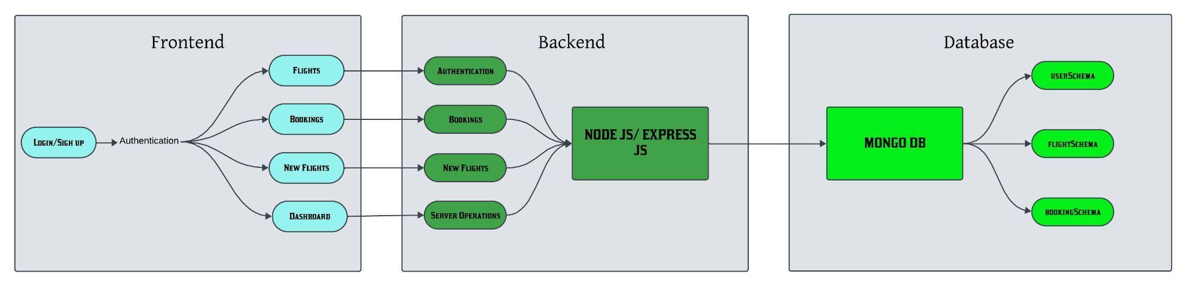
In this architecture diagram:
Frontend:
- Built using React.js
- Styled using Tailwind CSS
- Handles user interaction (Login, Register, Product Browse, Cart, Orders)
Backend:
- Built using Node.js and Express.js
- Handles API routing
- Manages authentication and business logic
- Connects to database
Database:
- PostgreSQL
- Managed using Drizzle ORM
- Stores Users, Products, Orders
Authentication:
- Encrypted passwords
- Session management
- Role-based access (Admin/User)

ER DIAGRAM
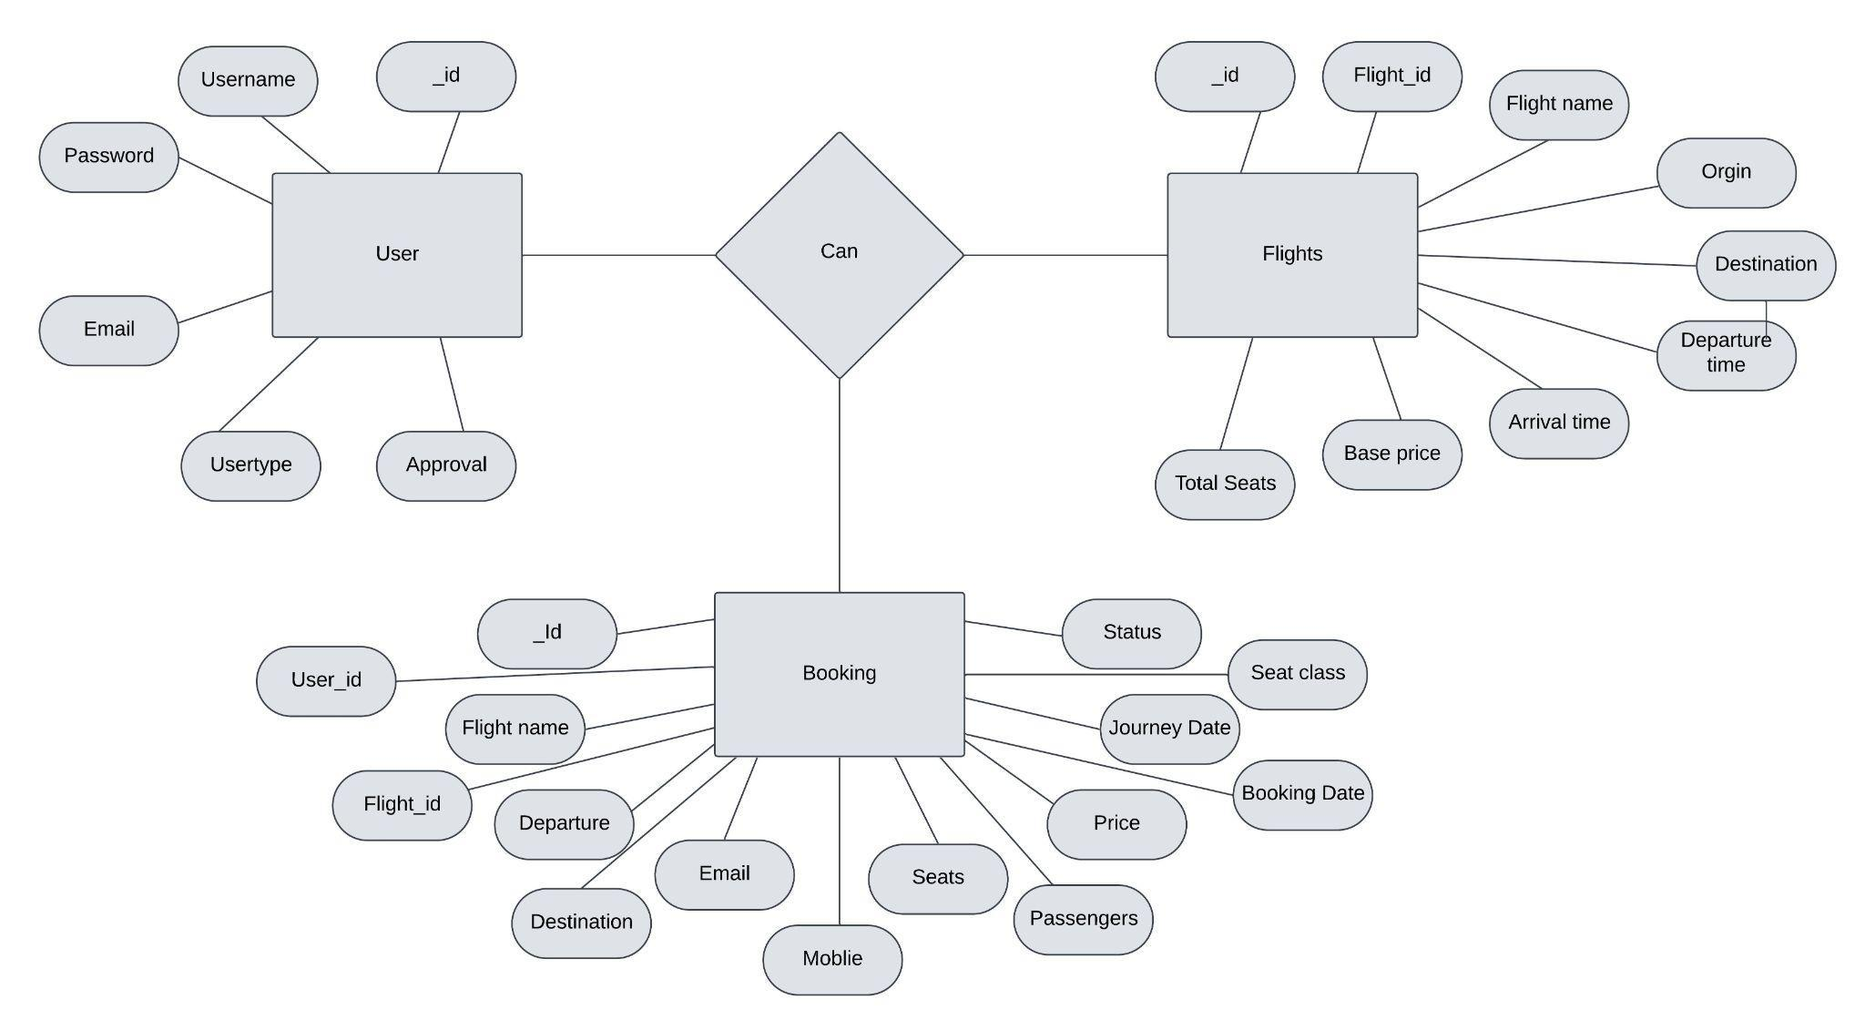

USER:
Represents customers who register and place orders. A user can have multiple orders.
PRODUCT:
Represents items available for purchase. Each product has price, description, stock quantity.
ORDER:
Represents a purchase made by a user. A user can create multiple orders.
ADMIN:
Manages products and monitors orders.
Relationships:
- One User → Many Orders
- One Product → Many Orders
- Admin → Manages Products

PREREQUISITES:
To develop a full-stack flight booking app using React JS, Node.js, and MongoDB, there are several prerequisites you should consider. Here are the key prerequisites for developing such an application:

Node.js and npm: Install Node.js, which includes npm (Node Package Manager), on your development machine. Node.js is required to run JavaScript on the server side.
- Download: https://nodejs.org/en/download/
- Installation instructions: https://nodejs.org/en/download/package-manager/
MongoDB: Set up a MongoDB database to store hotel and booking information. Install MongoDB locally using a cloud-based MongoDB service.
- Download: https://www.mongodb.com/try/download/community
- Installation instructions: https://docs.mongodb.com/manual/installation/
Express.js: Express.js is a web application framework for Node.js. Install Express.js to handle server-side routing,middleware, and API development.
- Installation: Open your command prompt or terminal and run the following command: npm install express
React.js: React.js is a popular JavaScript library for building user interfaces. It enables developers to create interactive and reusable UI components, making it easier to build dynamic and responsive web applications. To install React.js, a JavaScript library for building user interfaces, follow the installation guide: https://reactjs.org/docs/create-a-new-react-app.html
HTML, CSS, and JavaScript: Basic knowledge of HTML for creating the structure of your app, CSS for styling,and JavaScript for client-side interactivity is essential.
Database Connectivity: Use a MongoDB driver or an Object-Document Mapping (ODM) library like Mongoose to connect your Node.js server with the MongoDB database and perform CRUD (Create, Read, Update, Delete) operations.
Front-end Framework: Utilize Angular to build the user-facing part of the application, including product listings, booking forms, and user interfaces for the admin dashboard.
Version Control: Use Git for version control, enabling collaboration and tracking changes throughout the development process. Platforms like GitHub or Bitbucket can host your repository.
- Git: Download and installation instructions can be found at: https://gitscm.com/downloads
Development Environment: Choose a code editor or Integrated Development Environment (IDE) that suits your preferences, such as Visual Studio Code, Sublime Text, or WebStorm.
- Visual Studio Code: Download from https://code.visualstudio.com/download
- Sublime Text: Download from https://www.sublimetext.com/download
- WebStorm: Download from https://www.jetbrains.com/webstorm/download

To Connect the Database with Node JS go through the below provided link:
- https://www.section.io/engineering-education/nodejs-mongoosejs-mongodb
To run the existing Flight Booking App project downloaded from github:
Follow below steps:
Clone the repository:
- Open your terminal or command prompt.
- Navigate to the directory where you want to store the e-commerce app.
- Execute the following command to clone the repository:
Git clone: https://github.com/mosapraveen/shopez-hub.git
Install Dependencies:
- Navigate into the cloned repository directory:
cd Shopez-MERN
- Install the required dependencies by running the following command:
npm install
Start the Development Server:
- To start the development server, execute the following command:
npm run dev or npm run start
- The e-commerce app will be accessible at http://localhost:3000 by default. You can change the port configuration in the .env file if needed.
Access the App:
• Open your web browser and navigate to http://localhost:3000
• You should see the flight booking app's homepage, indicating that the installation and the setup was successful.
You have successfully installed and set up the flight booking app on your local machine. You can now proceed with further customization, development, and testing as needed.

PROJECT STRUCTURE:
- Inside the Flight Booking app directory, we have the following folders
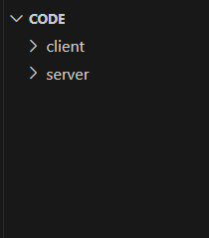

- Client directory:
The below directory structure represents the directories and files in the client folder (front end) where, react js is used along with Api’s.
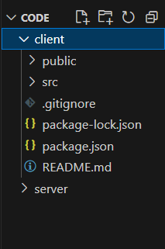
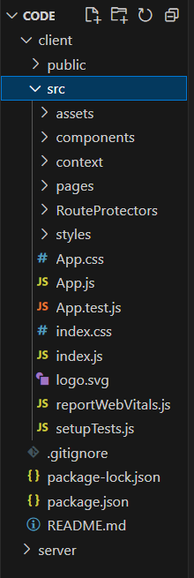
- Server directory:
The below directory structure represents the directories and files in the server folder (back end) where, node js, express js and mongodb are used along with Api.
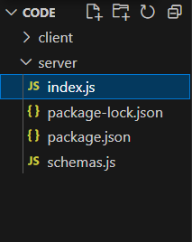

APPLICATION FLOW
USER:
- Register/Login
- Browse Products
- Add to Cart
- Place Order
- View Orders
- Cancel Order
ADMIN:
- Add Products
- Update Products
- Delete Products
- View All Orders
- Monitor User Activity

PROJECT FLOW:
Milestone 1: Project Setup
- Create frontend and backend folders
- Install required dependencies
Milestone 2: Backend Development
- Configure PostgreSQL
- Create Express server
- Define API routes
- Implement authentication
- Implement CRUD operations
Milestone 3: Database Development
- Define Drizzle schemas
- Connect database to backend
- Test database queries
Milestone 4: Frontend Development
- Implement Login/Register
- Create Product Listing UI
- Implement Cart
- Implement Order Page
- Admin Dashboard
Milestone 5: Final Testing & Deployment
- Functional testing
- API testing
- UI testing
- Bug fixing
- Prepare for cloud deployment

The demo of the app is available at:
https://drive.google.com/file/d/1xI7_nvN0pxdDpXiz7o1rAgDxfpChPD-k/view?usp=sharing

